29.49:a) (i) 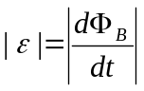
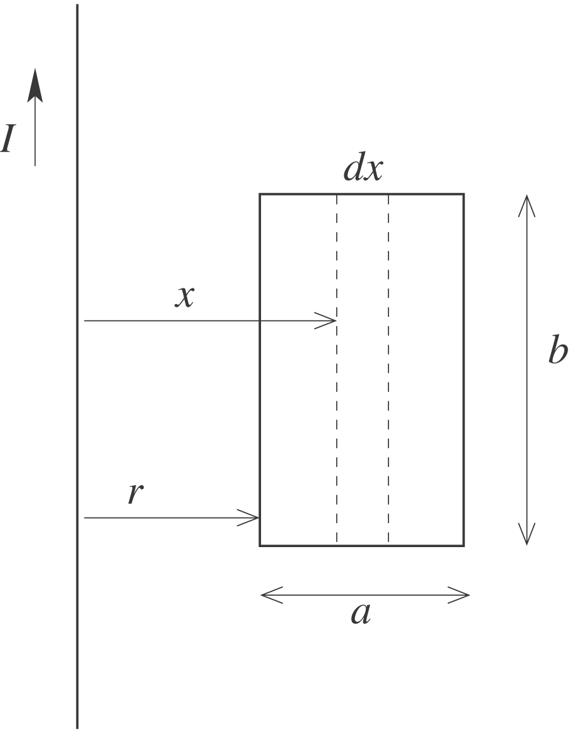
Consider a narrow strip of width 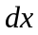and a distance from the long wire.
The magnetic field of the wire at the strip is 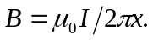
The flux through the strip is 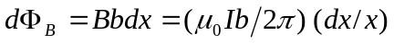
The total flux through the loop is 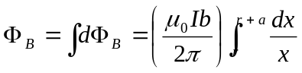
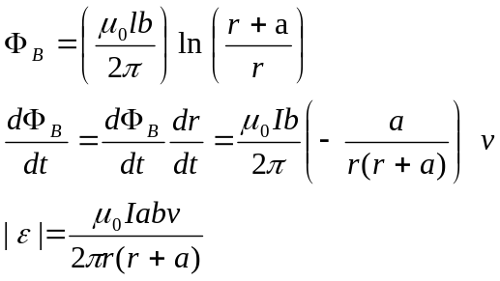

(ii) 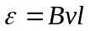 for a bar of length moving at speed perpendicular to magnetic field 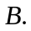

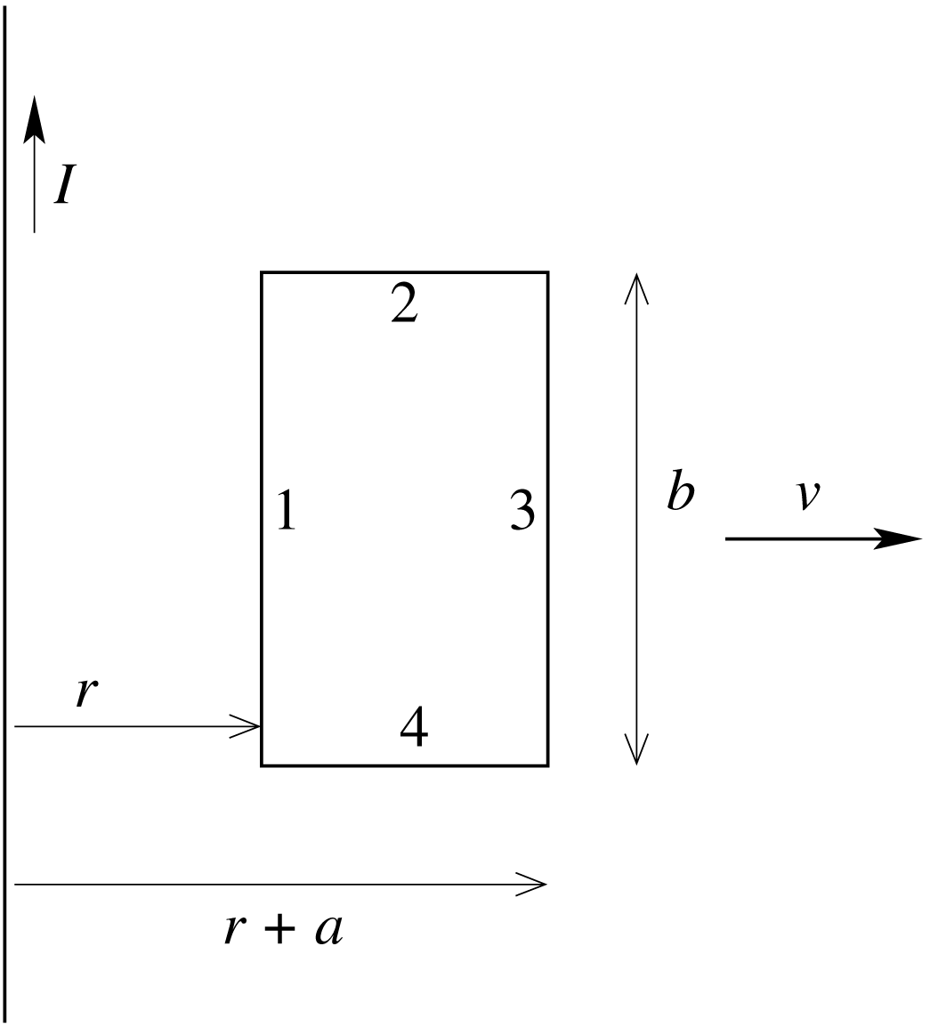
The emf in each side of the loop is
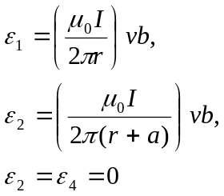
Both emfs 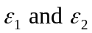 are directed toward the top of the loop so oppose each other. The net emf is
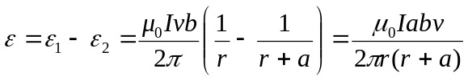
This expression agrees with what was obtained in (i) using Faraday’s law.

b) (i) 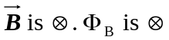 and decreasing, so the flux 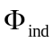 of the induced current is and the current is clockwise.

(ii)

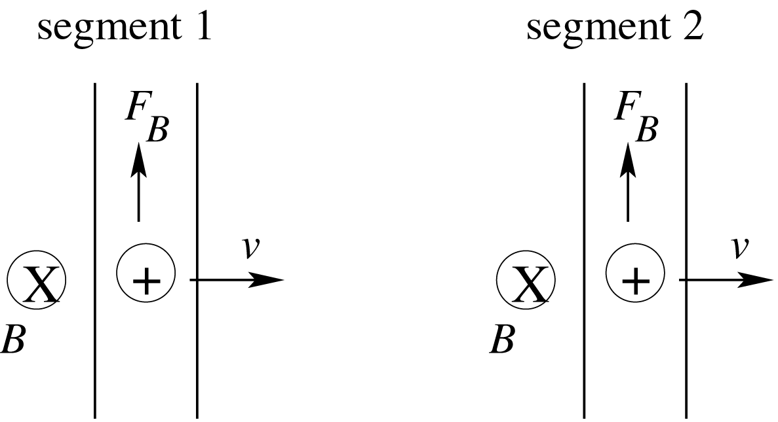

 is larger at segment 1 since it is closer to the long wire, so 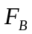 is larger in segment 1 and the induced current in the loop is clockwise. This agrees with the direction deduced in (i) using Lenz’s law.
c) when 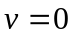 the induced emf should be zero; the expression in part (a) gives this. When 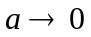 the flux goes to zero and the emf should approach zero; the expression in part (a) gives this. When the magnetic field through the loop goes to zero and the emf should go to zero; the expression in part (a) gives this.

